National Day in Singapore

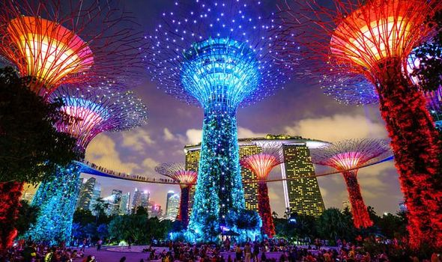

The Singapore National Day Parade (NDP) is an annual parade held in the city-state of Singapore. Held annually on 9 August, it is the main public celebration of National Day.

The National Day of Singapore is a public holiday, celebrated on August 9th each year. If August 9th falls on a weekend, then a public holiday will be observed on the following Monday.

First held on 9 August 1966 to mark the one-year anniversary of the Proclamation of Singapore, it has been held annually since. In recent years, it has usually been held at either The Padang, or The Float at Marina Bay. In the past, it was held at the former National Stadium.

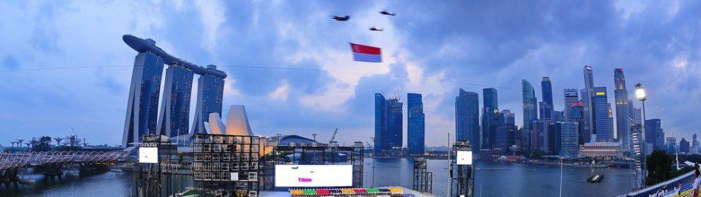

The nation celebrates its freedom from Malaysia on its National Day – the most popular among festivals in Singapore. Like all, it has a public display of its culture, heritage, defense, power, and diversity. Another special feature is the stunning display of fireworks on the eve of the day. Witness the elaborate celebrations of the Singapore National Day.

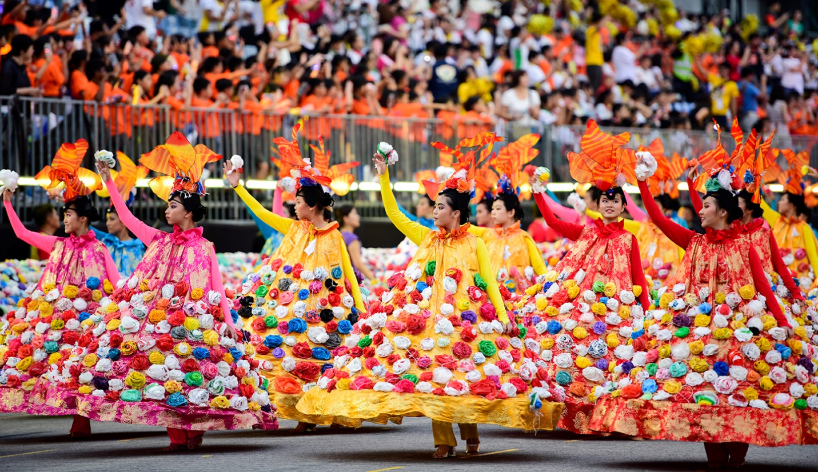

Singaporeans begin celebrations during the last weeks of July and they will continue throughout August. These celebrations will include concerts, carnivals, and many other festivities.

The largest event among the celebrations is the annual National Day Parade. The parade is held in Singapore’s National Stadium in front of 60,000 people and is nationally televised.

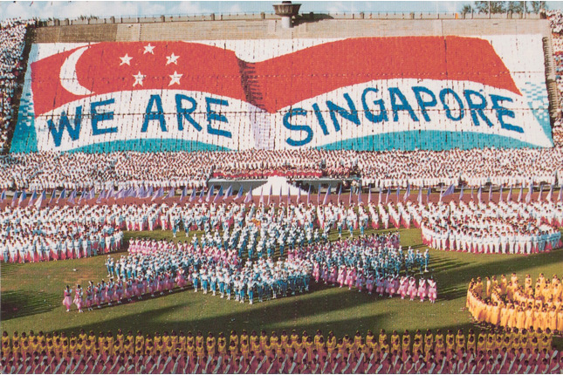

The parade features performances from military and school bands, a 400-piece drum ensemble, solo vocalists, professional dance routines, and displays by the Singapore Armed forces, which include free-fall parachute displays, tower repelling, vehicle shows, a presidential gun salute and a national flag fly-by.

**Don’t miss:**Fireworks at Marina Bay  
**When:**9th August 2020